|  |
| --- |
| PURBANCHAL UNIVERSITY  ACME ENGINEERING COLLEGE  SITAPAILA, KATHMANDU    FINAL PROJECT REPORT  ON  **COLLEGE ACCOUNTING SYSTEM**  SUBMITTED BY:  Aaju Chandra Shrestha (01)  Abin Raj KC (02)  Aliz Acharya (04)  Dipak Pandit (11)  DEPARTMENT OF COMPUTER AND ELECTRONICS & COMMUNICATION ENGINEERING |
|

**CONTENTS**

1. INTRODUCTION: 3

1.1. About the project: 3

1.2. Project Scope: 3

1.3. Objective: 4

2. LITERATURE REVIEW: 5

2.1. Why we need it? 5

3. METHODOLOGY 6

3.1. Software Development Life Cycle (SDLC) 6

3.2. Model Used 8

4. DESIGN 9

4.1. Context diagram 9

4.2. DFD(Data flow Diagram) 9

4.3. ER Model 11

4.4. Use Case Diagram 12

5. FLOWCHART: 14

5.1. Of main body: 14

5.2. Of Student Login: 15

5.3. Of teacher/staff login: 16

6. DISCUSSION & CONCLUSION: 17

7. FUTURE ENHANCEMENTS 17

8. REFERENCES 18

9. SNAPSHOTS 19

# INTRODUCTION:

## About the project:

This mini project in C i.e. College accounting system was developed by me and my friends for project submission during the 3rd semester. In this project, we performed accounting operations under two account types: one for the students and one for teachers and staffs.

This project is complete and totally error-free. It utilizes functions and data structures, and is capable of handling logins, encrypting passwords, holding, editing and deleting records and also provide billing facility like dues, etc.

College Accounting System is a console application with graphic. It is compiled in turbo C with gcc compiler.

## Project Scope:

In this modern world, people are still using manual accounting processes. Being a part of modern world, Nepal is still lacking the digitization in all the fields. Likewise in our college, there is still manual accounting which results in heavy time loss, overuse of manpower and also dissatisfaction of the students. So, we are developing a system that takes care of accounting in our college.

* It can be used as a primary accounting system for any businesses.
* All the records are kept secure.
* It can be used for billing as well.
* To increase the speed and satisfaction of all the members of the college including teachers and students.

## Objective:

The main objective of this project is to illustrate the requirement of accounting system in our college. The main objectives of the project are:

* To design and create a program which deals with everyday struggles in the accounting field in easy and secured way and to provide accurate reporting to the staffs.
* To provide record managing, editing, deleting and viewing facility & timely access to required records.
* This software will keep track of all the information of students & simplifies search/ discovery of a particular student in records.

# LITERATURE REVIEW:

The modern method of accounting is based on the system created by an Italian monk Fra Luca Pacioli developed over 500 years ago. This great and scientific system was so well designed that even modern accounting principles are based on it. But during the development period of over 500 years, the accounting and billing systems have progressed a lot up to the modern times. There may have been the manual origins to this, but suitable to these modern digital era many systems have been created with many facilities like cloud hosted accounting, new developed interface, time tracking, task management, organizing the information and many other services that are essential.

Many accounting sectors are operated manually by group of people. These people keep records regarding students, check their records manually and if the accounting sector is very large, proper record keeping will become a major problem as manual record keeping and billing has never been a reliable method because people tend to forget many things.

Some other problems such as:

* Fast report & billing is not possible.
* Record finding is difficult.
* Information about dues and salary is not properly maintained.
* Billing records of student are cumbersome.

So, to tackle such problem we have to select the project College Accounting System.

## Why we need it?

* In today's computerized, interconnected, global business environment, the accounting and billing profession must deal with a host of complex issues that never existed in the past.
* Improve service through greater access to accurate information.
* More economical and safer means of storing and keeping track of information.
* Reduces error and eliminates long and repetitive manual processing.
* Improved efficiency and effectiveness of accounting in the college.
* More reliable security for sensitive and confidential information.

# METHODOLOGY

## Software Development Life Cycle (SDLC)

SDLC is a systematic process followed for building a software project, within a software organization that ensures the quality and correctness of the software built.. It consists of a detailed plan describing how to develop, maintain, replace and alter or enhance specific software. The software development should be completed in the pre-defined time frame and cost.

Every phase of the SDLC lifecycle has its own process and deliverables that feed into the next phase.

A typical Software Development Life Cycle consists of following phases:

Figure 1phases of SDLC

Planning

Analysis

Design

Implementation

Maintenance

* System planning

The system planning is done under following headings:

* System identification and selection

At first step, what kind of system is being is developed is identified along with identification of the required needs. The choice of whether developing an entirely new system or modification of existing one is to be done is also made.

* System initiation and planning

In this phase, the feasibility studies are made in order to make sure that the system is feasible to develop or not. The data is collected from different sources and then converted to a meaningful one.

* System Analysis

The developer becomes best familiar to the system going to be developed in this phase. Here, hardware and software requirements of the system are identified and finalized along with analyzing the best possible ways to solve the problem occurring. Many different parts of the system are studied in order to identify its true objective.

* System Design

This is the phase where the blueprint of the system is developed. It focuses on how to accomplish the objective of system and decides how the software will perform on many terms.

* System implementation

This phase can be further divided into two different parts:

* System development

The system is developed according to the given design specifications. Different tasks like coding, testing and debugging and documentation are carried out during this process.

* System installation

After the complete development of the system, it is installed on the machine meeting the hardware and software requirements to perform its objective. During this phase, the practical tasks like system installation in client’s machine, training new users about system use and taking feedbacks from the users and implementation of modifications are accomplished.

* System support and maintenance

Once the system is brought to practical use, then it needs further future support and maintenance for maintaining efficiency and longevity of the system. This includes assisting the users in solving the unanticipated problems, fixing the defects and bugs within the system and adopting system to new requirements. These steps are very important to keep the system running and useful.

## Model Used

Among many models of SDLC, the waterfall model was used in development of this project.

Waterfall model also known as linear sequential life cycle model was the earliest SDLC approach that was used for software development. This model illustrates the software development in linear sequential flow. Any phase in the development process begins only if the previous phase is complete and the phases do not overlap in this model.

Waterfall model is widely used in Software Engineering to ensure success of project. The whole process is divided into different phases and the outcome of one phase acts as input for next phase sequentially.

The following illustration is a representation of the different phases of the Waterfall model:

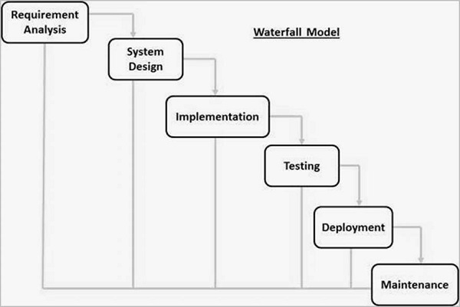

Reasons behind selection of waterfall model for our project:

* Requirements are very well documented, clear and fixed.
* Product definition is stable.
* Technology is understood and is not dynamic.
* There are no ambiguous requirements.
* Plenty resources with required expertise are available to support the product.
* The project is short.
* Clearly defined stages.
* Easy to arrange tasks.

# DESIGN

## Context diagram

A context diagram is the diagram is the diagram that defines the scope and boundary for the system and its environment showing the entities it react with. It describes the highest level view of a system. It consists of all the external agents and all the data flows into and out of a system.

Context diagrams can be developed with the use of two types of building blocks:

* Entities (Actors): labeled boxes; one in the center representing the system, and around it multiple boxes for each external actor
* 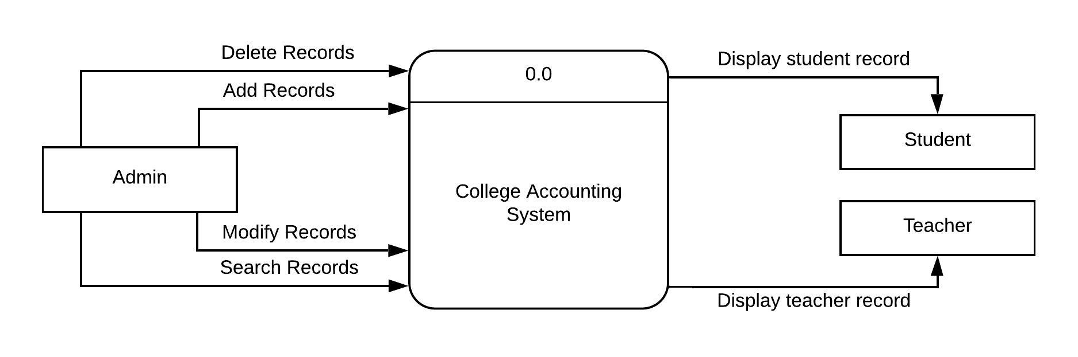Relationships: labeled lines between the entities and system

Figure 2Context Diagram

Here, the admin/user of the system has rights to add, delete, modify or search records. The teacher and student can view the required data.

## DFD(Data flow Diagram)

A data flow diagram (DFD) is a way of representing a flow of a data of a process or a system (usually an information system). The DFD also provides information about the outputs and inputs of each entity and the process itself. A data flow diagram has no control flow, there are no decision rules and no loops. Specific operations based on the data can be represented by a flowchart.

DFD provides an overview of:

* what a system would process
* what transformation of data are done
* what data are stored and which stored data are used
* where the result flows.

The different elements of a DFD are:

* Process:

The process (function, transformation) is part of a system that transforms inputs to outputs. The symbol of a process is a rectangle with rounded corners. The process is named in one word, a short sentence, or a phrase that is clearly to express its essence

* Entity(Source/Sink):

It represents a human system or sub system where a certain data comes from and goes to.

* Data Store:

A data store is used to store the data for future use. It does not have to be just a data file, for example, a folder with documents, a filing cabinet, and optical discs.

* Data flow:

It shows the transformation of information from one system to another (sometimes also material). It is denoted by a line with arrowhead where the direction of arrowhead represents the direction of flow of data.

**Leveling of DFD:**

It is the process of expanding a context diagram providing more details. Generally, top down approach is used where we start with an overview and then moving on with the details one by one. There are three levels of developing DFD. They are:

* Level 0 DFD Diagram
* Level 1 DFD Diagram
* Level 2 DFD Diagram

**Level 0 DFD Diagram:**

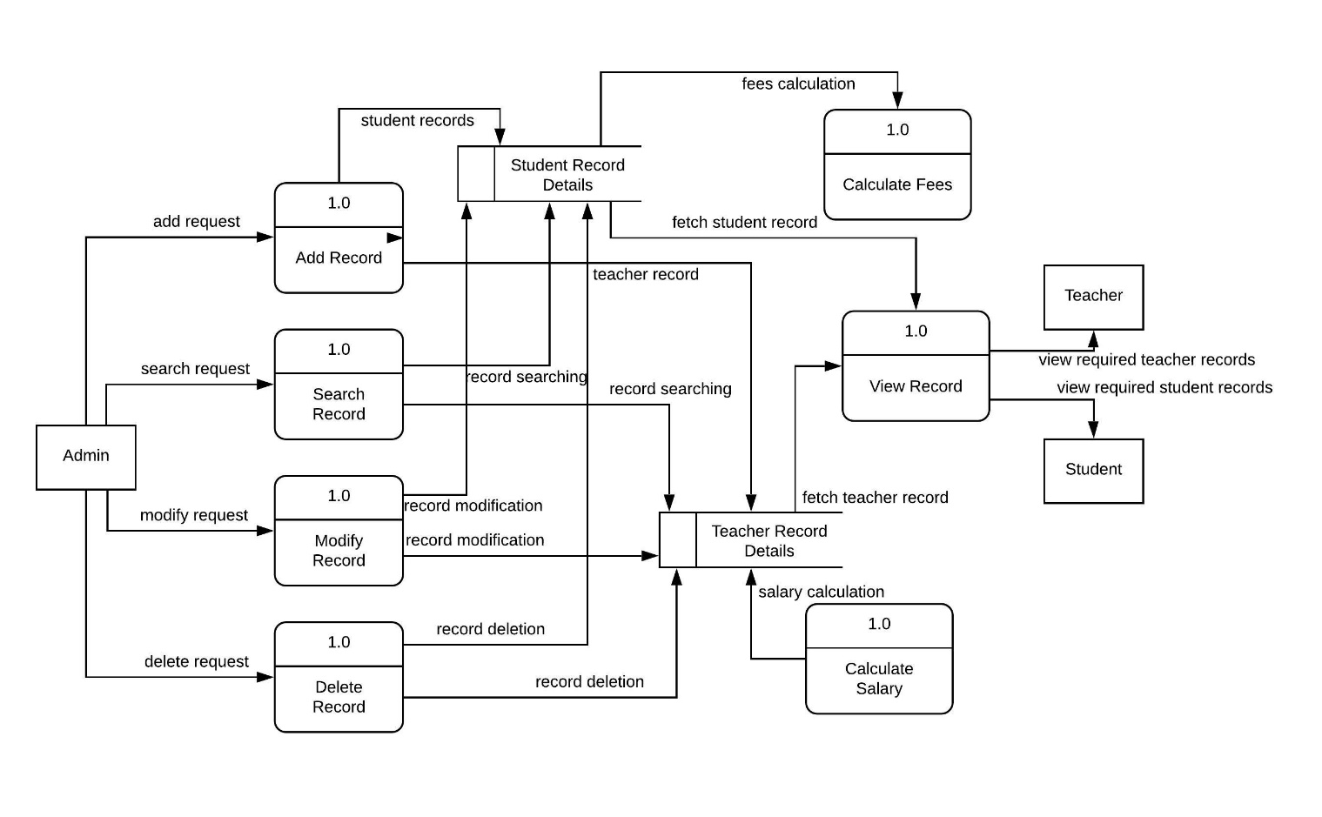The single main process of the context diagram s broken down into two or more processes of the system. It shows overall process of the system.

Figure 3Level 0 diagram

## ER Model

An entity relationship model*,* also called an entity-relationship (ER) diagram*,* is a graphical representation of entities and their relationships to each other, typically used in computing in regard to the organization of data within databases or information systems. An entity is a piece of data-an object or concept about which data is stored.

It is expressed in terms of entities and their attributes or characteristics.

Figure 4ER diagram

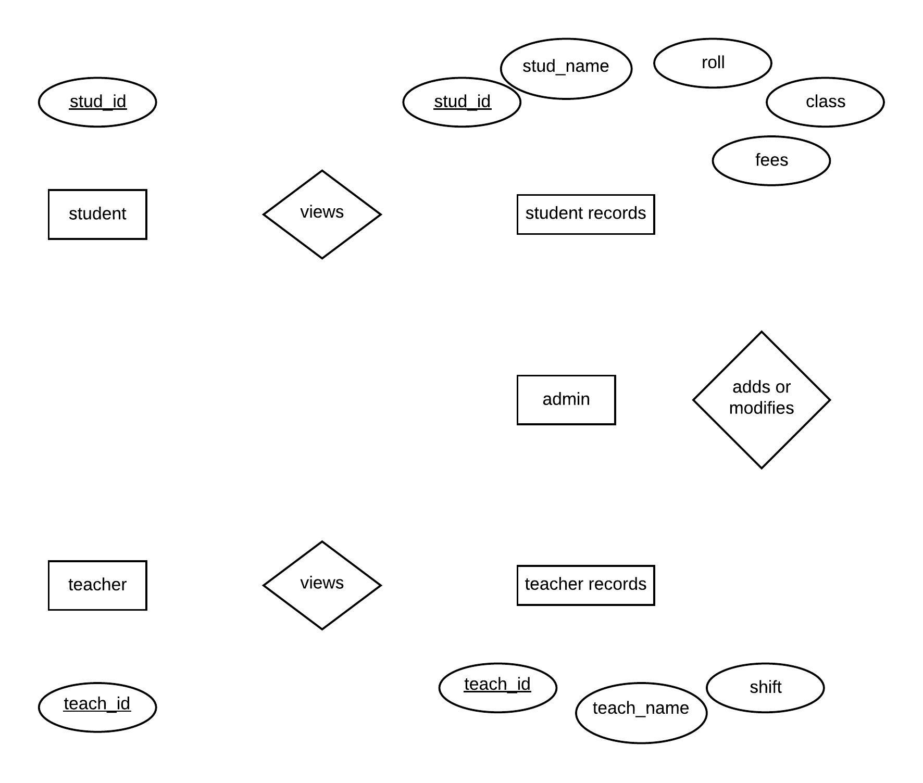

Admin can perform operations like addition of data or modification of records. One admin can add or modify data record of one or many students or records. The {stud_id} and {teach_id} are the primary keys. One Student or teacher can view the either zero or a single record from the data record. The {stud_id}and {teach_id} is needed to view the required record which respectively emplies the student and teacher’s id,

## Use Case Diagram

A use case diagram at its simplest is a representation of a user's interaction with the system that shows the relationship between the user and the different use cases in which the user is involved. A use case diagram can identify the different types of users of a system and the different use cases and will often be accompanied by other types of diagrams as well. The use cases are represented by either circles or ellipses.

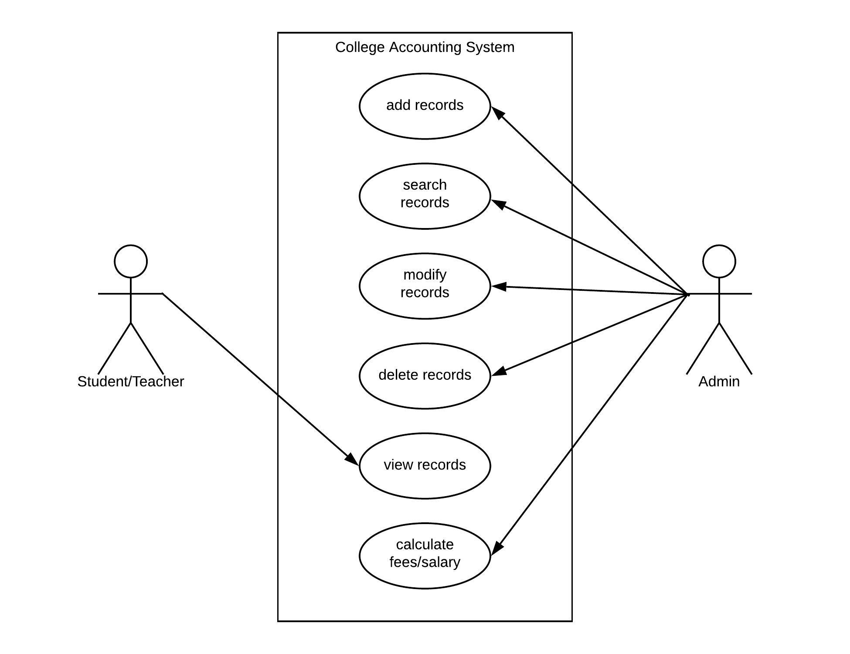

Figure 5Use Case Diagram

In the program, admin ether adds, searches, modifies or delete records. They can also calculate fees/salary of students/teacher from the database. The student and teacher can view their respective records.

# FLOWCHART:

## Of main body:

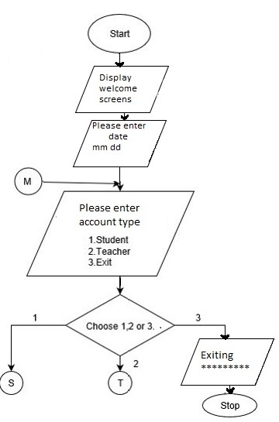

## Of Student Login:

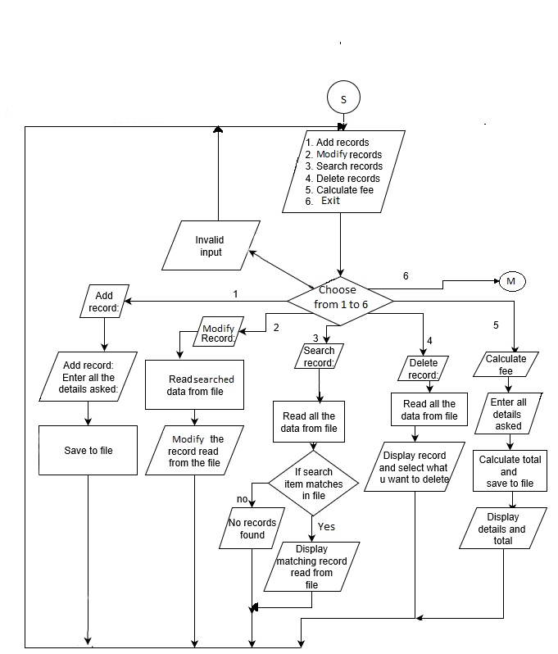

## Of teacher/staff login:

# DISCUSSION & CONCLUSION:

An Accounting system will be developed which will be capable of adding the required records, viewing those entered records, searching the required records, modification of the existing records, or deleting them, calculating the fees and saving all these information to a file. Moreover the system shall be available for different user profiles that grants different rights to different users. Thus, a system will be built that grants easy, effective and secure application on the practical field.

# FUTURE PLANS

College Management System is one of the most used system in College and Institutions to keep records and manage the records of students and staffs in the system. Even if there are many promises and developments done in this System, this system developed still lacks behind from being perfect in many aspects.

Some of the drawbacks in this system are:

* Graphics can be implemented better.
* The system is offline.
* Small bugs are available in the system.
* Password cannot be changed.
* Few features.

So, to make this system better, realistic and more perfect, we plan on making following enhancements on the future:

* Improve user interface
* Available of cloud hosting services.
* Fix the bugs.
* More features like printing the bill can be added.
* Ability to change the administrator passwords.
* Addition of records according to batch.
* Improve security through different means(fingerprint, ID cards)

# REFERENCES

1. https://www.Draw.io/flowchart

1. <https://impact.zewo.ch/en/impact/step1_define_objectives/project_objective>
2. <https://www.scribd.com/document/332746808/Introduction-Mini-Project>
3. <https://www.sciencebuddies.org/science-fair-projects/science-fair/sample-conclusions>
4. <https://en.wikipedia.org/wiki/Data_flow_diagram>
5. <https://www.tutorialspoint.com/sdlc/sdlc_waterfall_model.htm>
6. <https://www.guru99.com/software-development-life-cycle-tutorial.html>

# SNAPSHOTS

FIG: WELCOME SCREEN

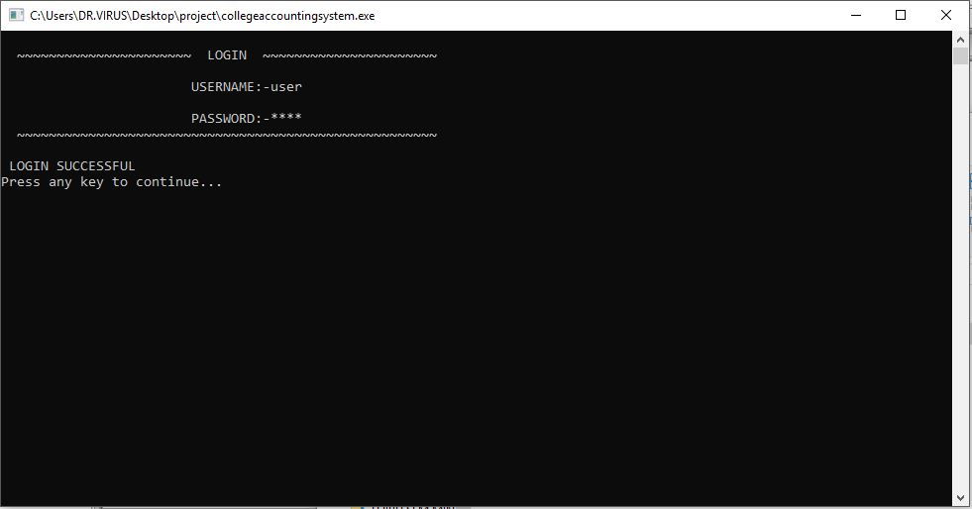

FIG: LOGIN SCREEN

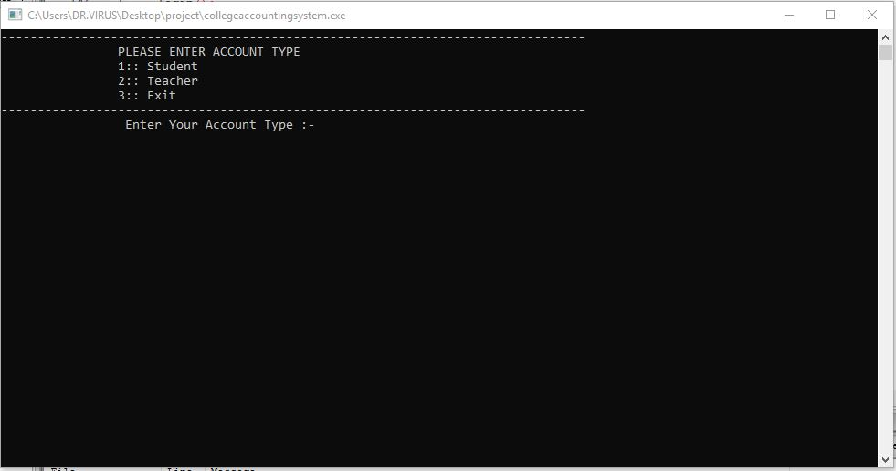

FIG: ACCOUNT TYPE SELECTION

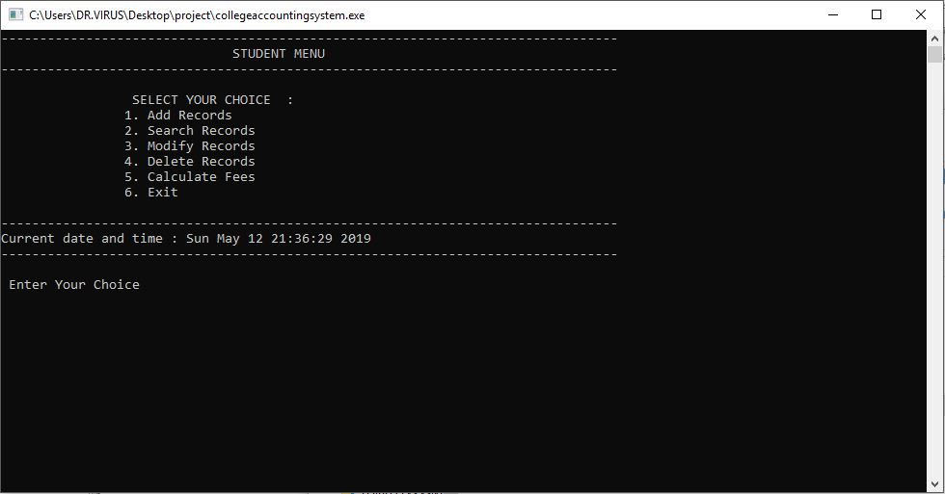

FIG: STUDENT ACCOUNT MENU

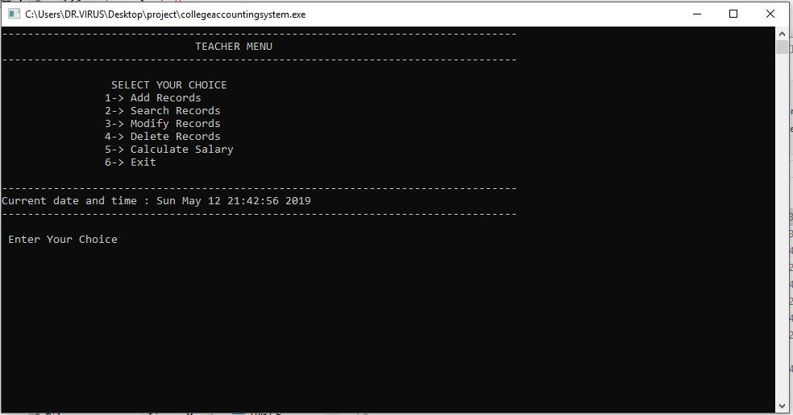

FIG: TEACHER ACCOUNT MENU

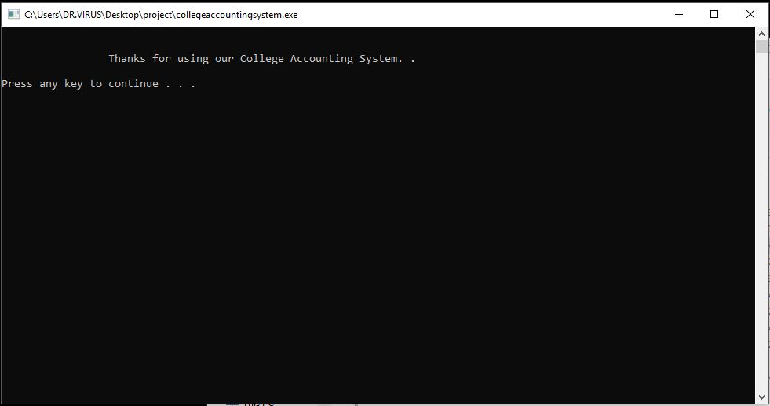

FIG: EXIT SCREEN